

**2022**



Designed BY: MUHAMMAD BASIT MUKHTAR

Dated: May 26, 2022

**Table of Contents**

Certificate of Completion 3

Acknowledgement 4

Project Synopsis 5

Functional Requirement 6

Problems Statement: 8

Proposed System **Error! Bookmark not defined.**

Hardware and Software Requirements 10

Website Features 11

Flow diagram 12

User Guide 13

• Homepage (landing Page) 13

• ABOUT US 14

• EXPERT TIPS 15

OUR STORES 17

• MAIN NAVIGATIONS: 18

➢ COOKWARE: 18

➢ REFRIGERATION: 19

➢ APPLIANCES: 19

➢ FOOD STORAGE: 20

COMPARE PRODUCTS: 21

SUB-DIVISIONS OF COOKWARE: 22

o COOKING POTS: 22

o COOKING PANS: 22

o COOKWARE SETS: 23

o HANDI’S 23

o KADAI’S(KARAHI) 24

o GRILL PANS 24

o TAWAS 25

o EGG POACHERS 25

o STEAMERS 26

SUB-DIVISIONS OF REFRIGERATION: 27

o FREEZERS 27

o REFRIGERATOR 27

SUB-DIVISIONS OF APPLIANCES: 28

o BLENDER 28

o BREAD MAKER 28

o COFFEE MAKER 29

o ICE CREAM AND SORBET MAKER 29

o ELECTRIC KETTLE 30

o FOOD CHOPPER 30

o TOASTERS 31

SUB-DIVISIONS OF FOOD STORAGE: 32

o FLASK 32

o SPICE JARS 32

o STORAGE BAGS 33

o LUNCH BOXES 33

o VACCUM BOTTLES 34

Developer’s Guide 35

COOKWARE 35

APPLIANCES 36

FOOD STORAGE 36

COMPARE PRODUCT **Error! Bookmark not defined.**

Task Sheet 37

# *Certificate of Completion*

This is to certify that **Muhammad Basit Mukhtar S/o. Muzammil Naeem** have successfully completed their First Web Designing Project.

Submitted to: **Aptech Computer Education**

On

**May 27th , 2022**

# *Acknowledgement*

First of all we would like to thank Almighty Allah for giving us strength and ability to complete this project.

And then, we would like to express my special thanks of gratitude to our teacher **Sir Mansoor Ahmed** who guided us on the project ***Kitchen Appliances***, which also helped us in doing a lot of new learning and we came to know about so many new things we are really thankful to him.

We are highly thankful to **Sir Mansoor Ahmed** for his guidance and constant supervision as well as for providing necessary information regarding the project & also for his support in completing the project.

Lastly, we would also like to thank our parents and friends who helped us a lot in finalizing this project within the limited time frame. We also express our sincere gratitude to I-Project team from Aptech Head Office, for their valuable guidance and support for the completion of this project. We earnestly hope that this project will provide all the necessary information required by the user to fulfill his/her inspiration. However, suggestion and Feedbacks for improvements will be thankfully welcomed & acknowledged*.*

# *Project Synopsis*

TASHA- *the home store* is Branded Company famous for home kitchen appliances. It provides collection of n number of appliances with different category to match the fast life of the generation. The Tasha group of companies had made huge profit in the year 2013. In order to enhance its business, we’re developing their site.

# *Functional Requirement*

1. Home Page
2. Categories
   1. Cookware
   2. Appliances
   3. Refrigeration
   4. Food Storage
3. With Sub- Categories Of:
   1. Cookware

Cooking Pots

Cooking Pans

Frying Pans

Handis

Kadais

Grill Pans

Tawas

Egg Poachers

Steamers.

* 1. Refrigeration

Refrigerators

Freezers

* 1. Appliances

Blender

Bread Maker

Coffee Maker

Ice-Cream And Sorbet Makers

Electric Kettles

Food Choppers

Toasters.

* 1. Food Storage

Flask

Spice Jars

Storage Bags

Lunch Boxes

Vaccum Bottles.

1. Support Links Like..
   1. About Us
   2. Manuals
   3. Our Stores
   4. Contact Us
2. Store Locators

# *Problems Statement:*

TASHA- *the home store* is Branded Company famous for home kitchen appliances. It provides collection of n number of appliances with different category to match the fast life of the generation. The Tasha group of companies had made huge profit in the year 2013.

# *Hardware and Software Requirements*

**Hardware**

* A minimum computer system that will help you access all the tools in the courses is a Pentium 166 or better
* 64 Megabytes of RAM or better

**Software**

* Notepad/HTML editor
* Dreamweaver
* IE 5.0/ Netscape 6.0

# *Website Features*

This website TASHA-the home store, contains almost all of the kitchen machines and appliances. So, the development of this website gives people to purchase their kitchen equipment by single click.

This site contains pictures and description along with their prices of all those products which they were selling in their store.

# *Flow diagram*

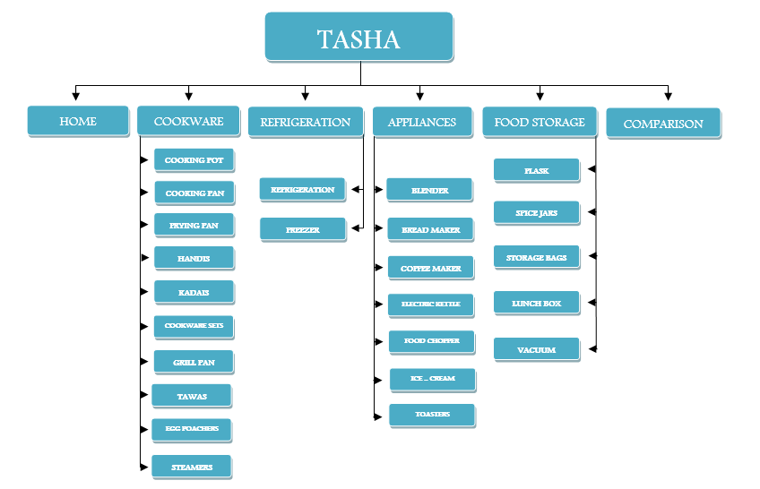

# *User Guide*

* *Homepage (landing Page)*

*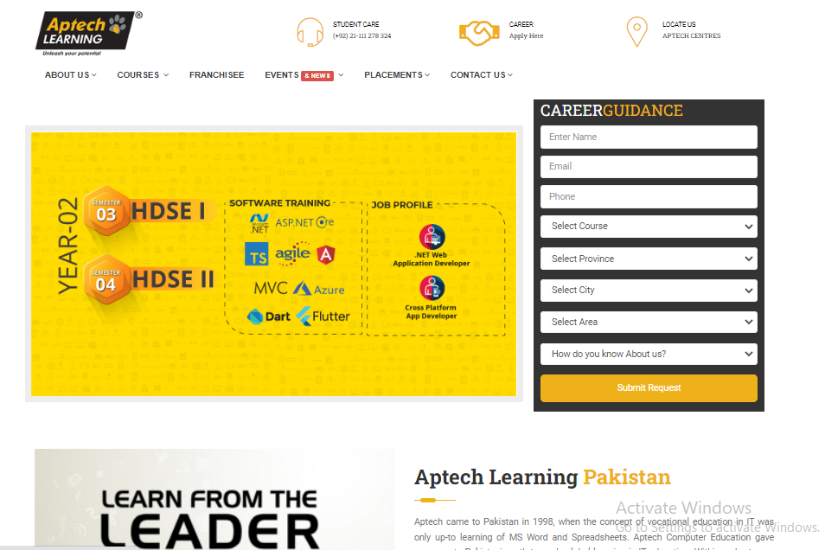­*

* *ABOUT US*

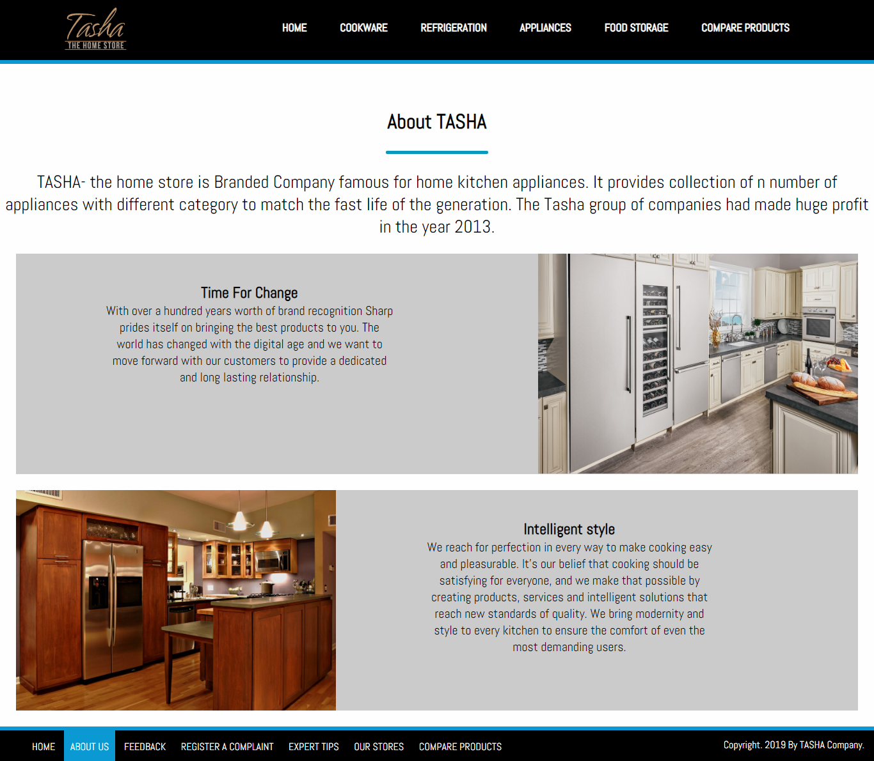

* *EXPERT TIPS*

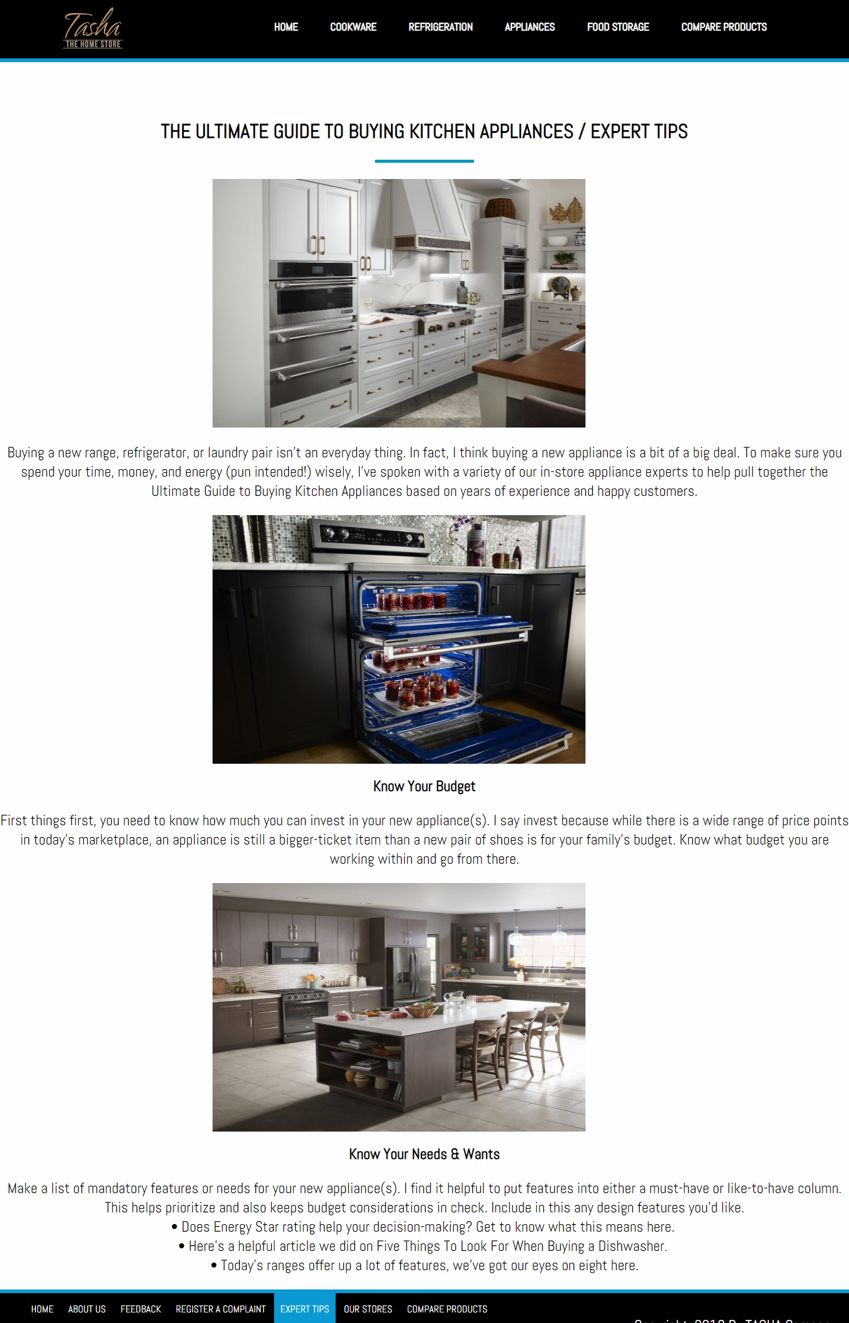

*OUR STORES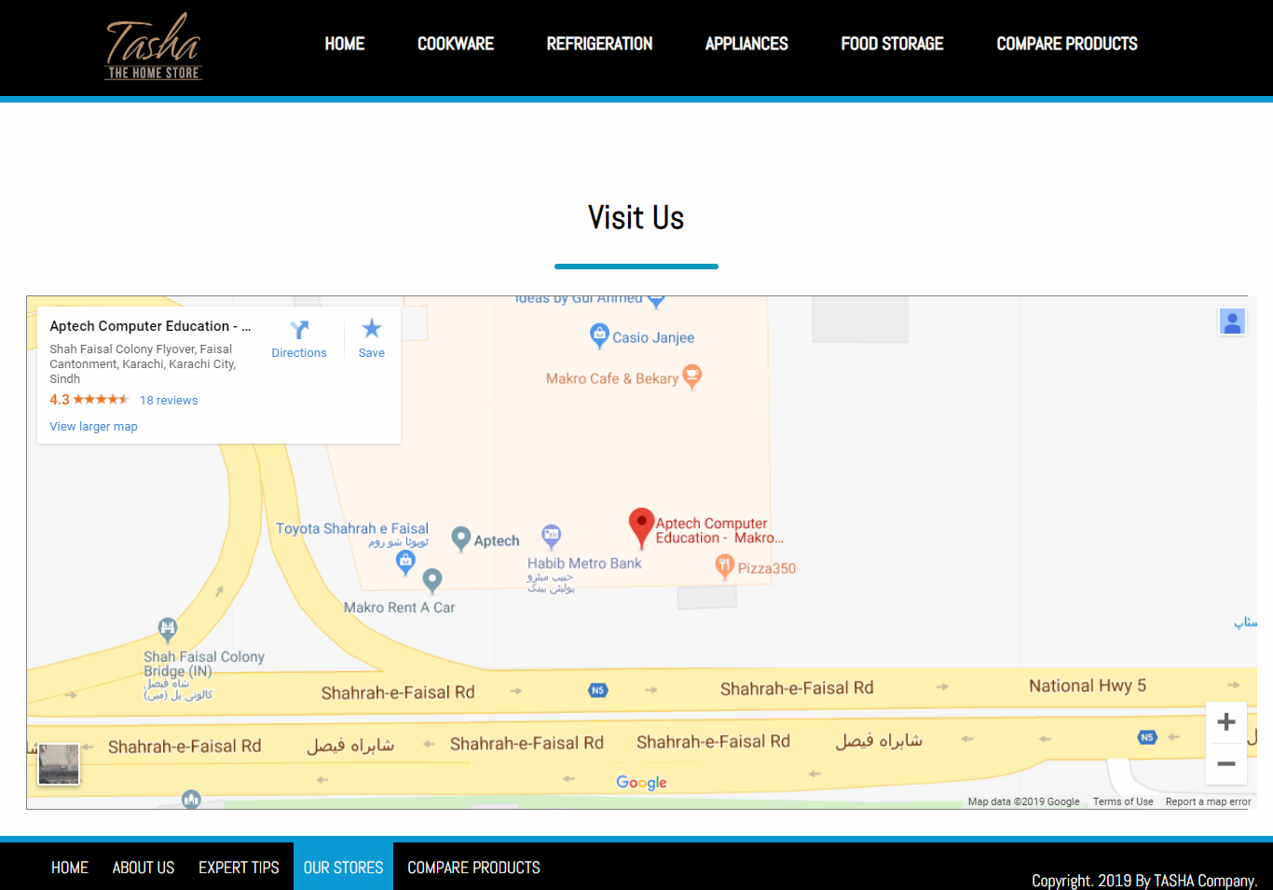*

* *MAIN NAVIGATIONS:­­­­­*
* *COOKWARE:*

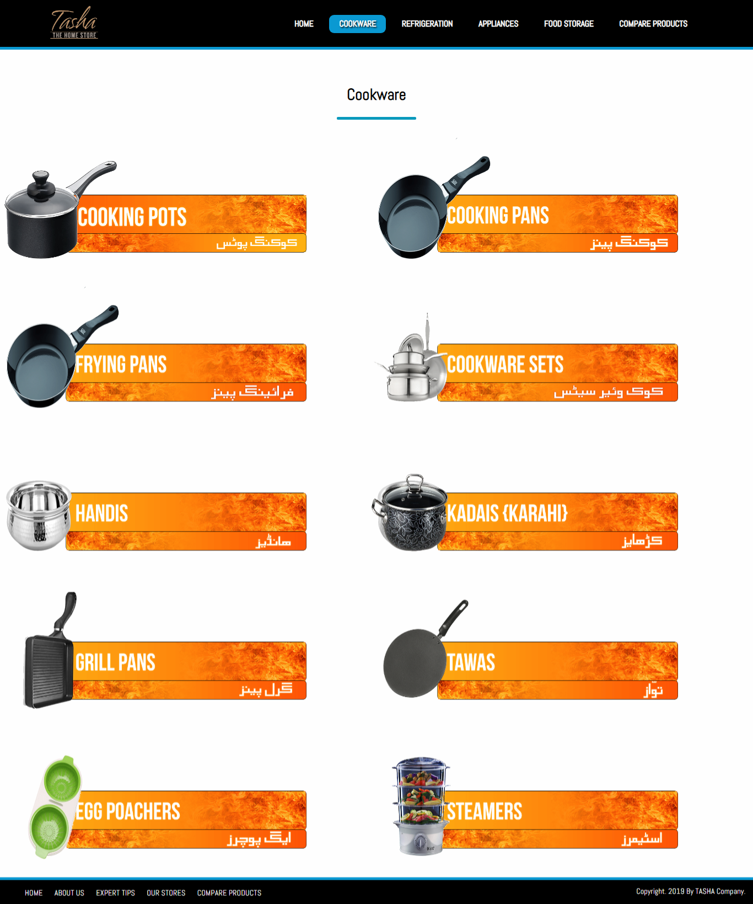

* *REFRIGERATION:*

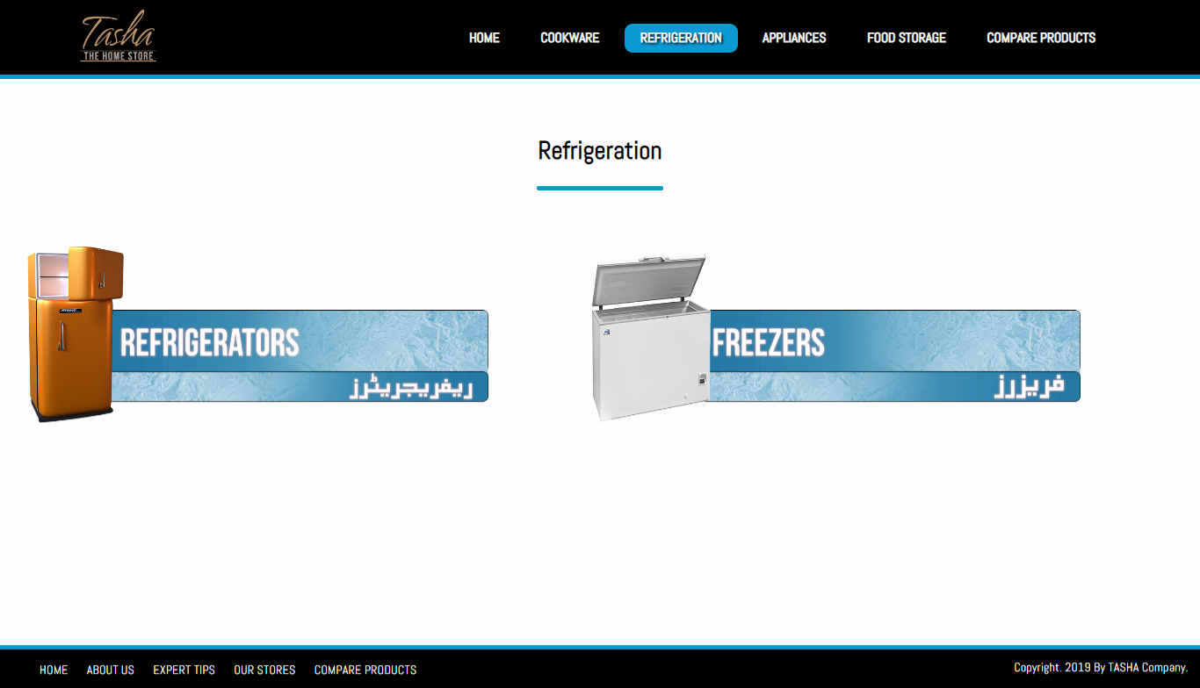

* *t:*

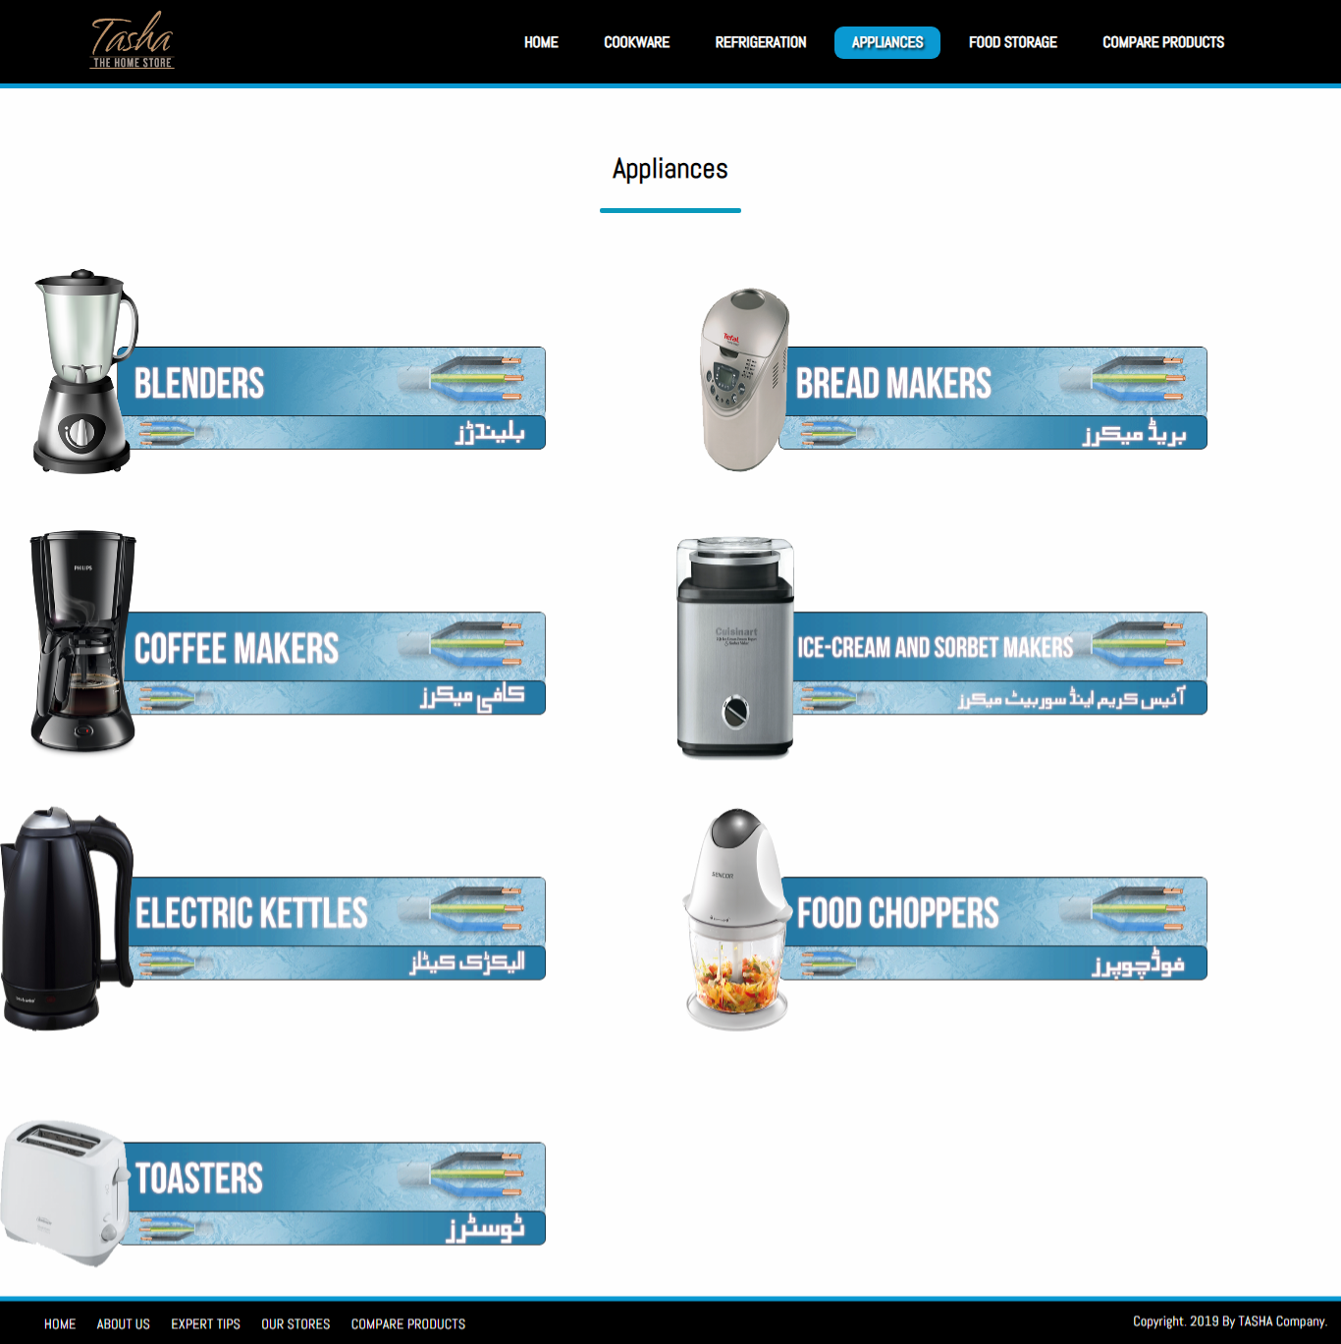

* *FOOD STORAGE:*

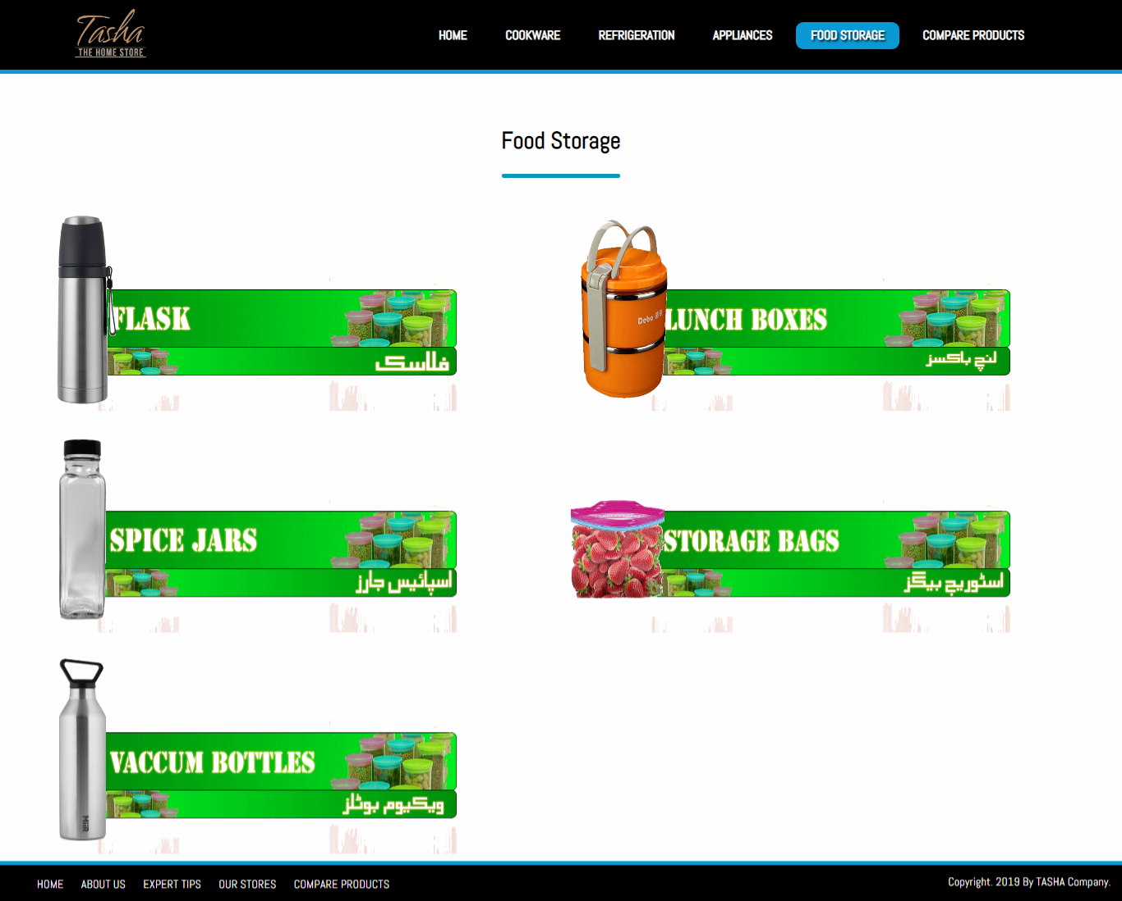

### *COMPARE PRODUCTS:*

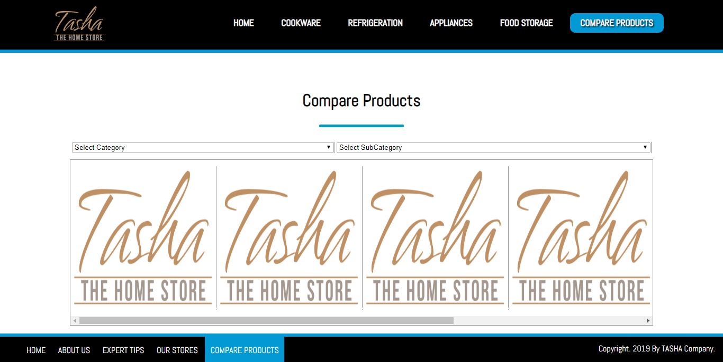

## SUB-DIVISIONS OF COOKWARE:

* *COOKING POTS: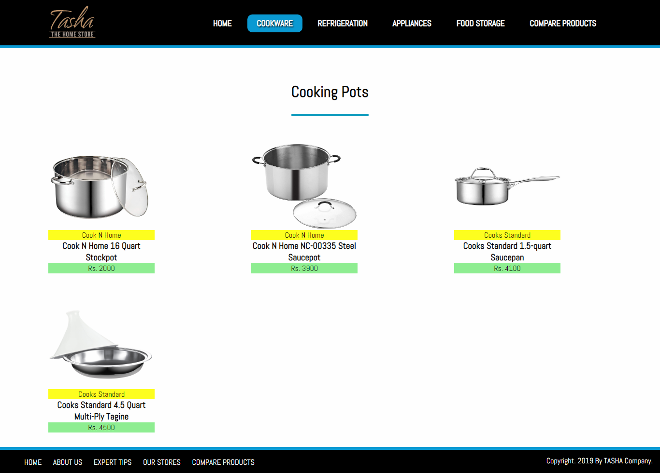*
* *COOKING PANS:*

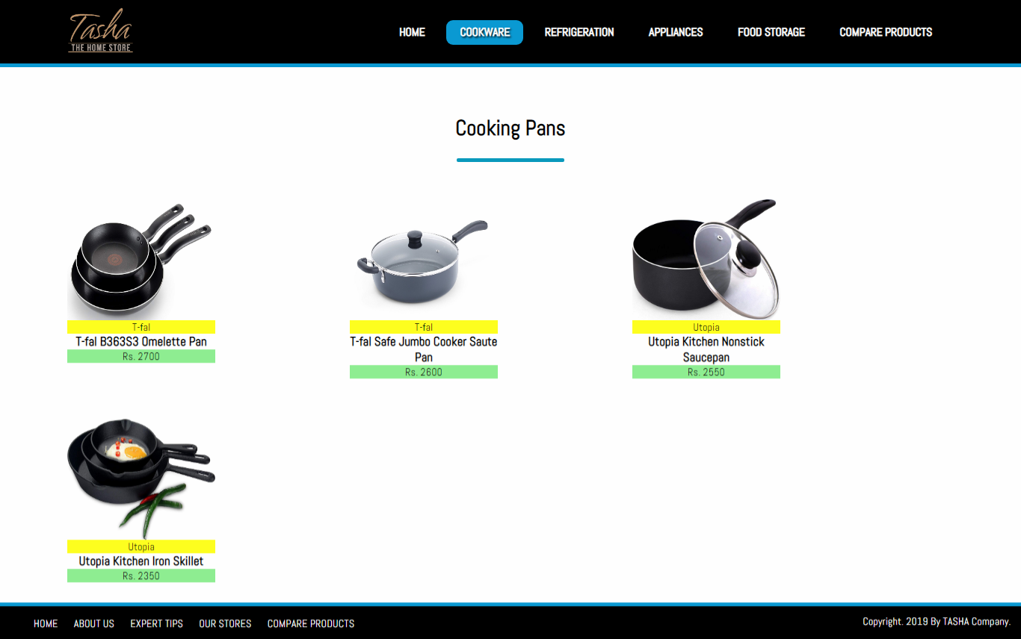

* *COOKWARE SETS:*

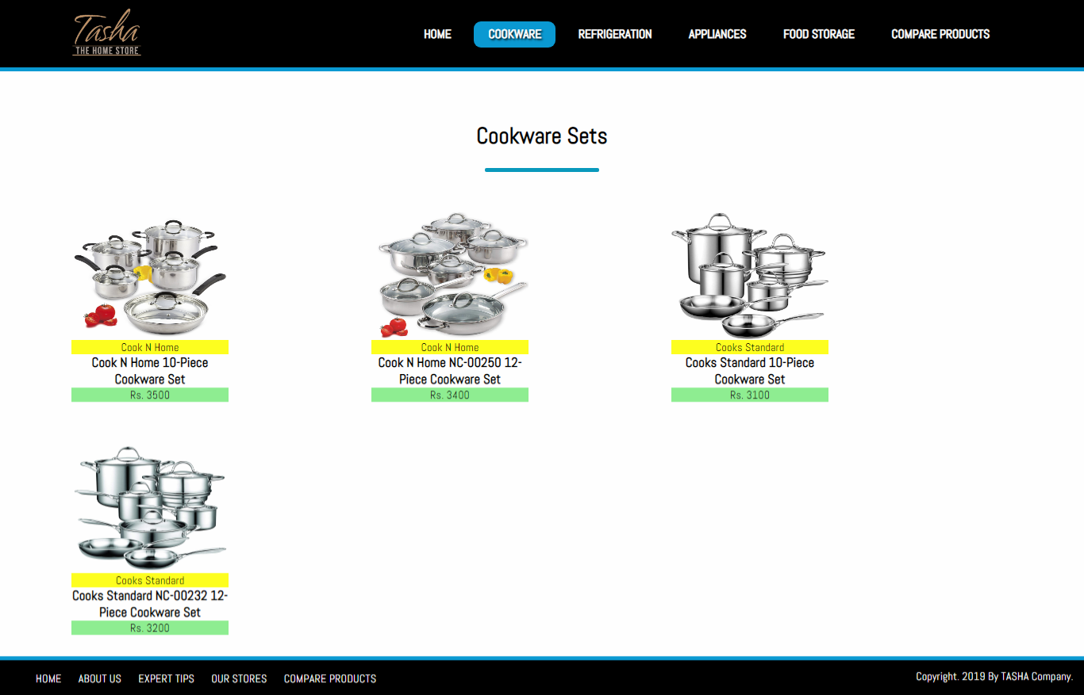

* *HANDI’S*

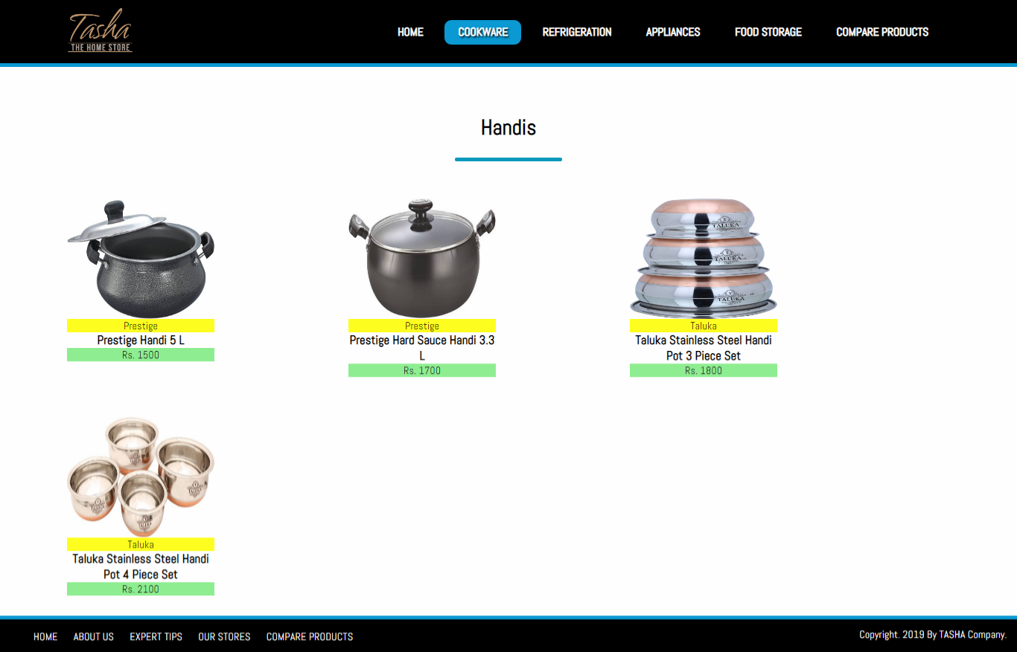

* *KADAI’S(KARAHI)*

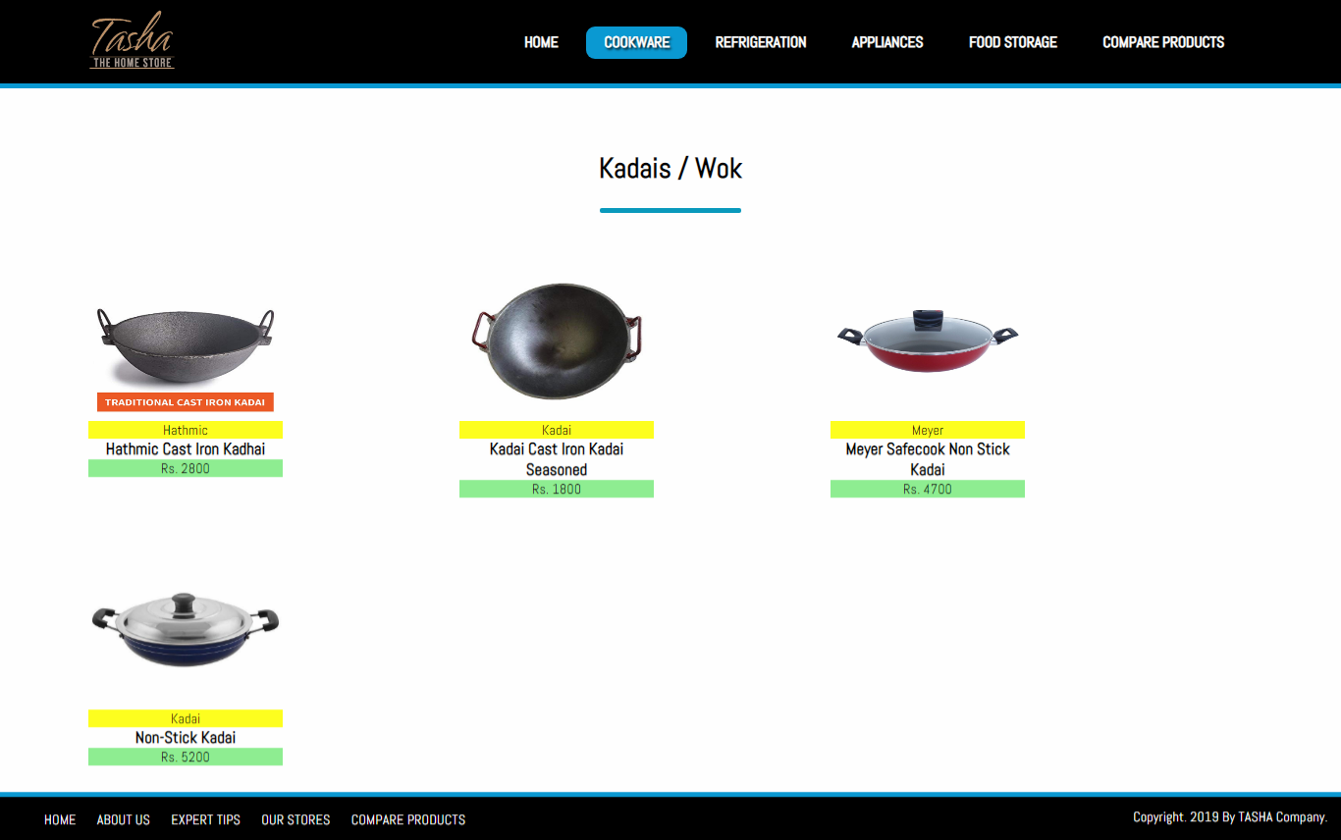

* *GRILL PANS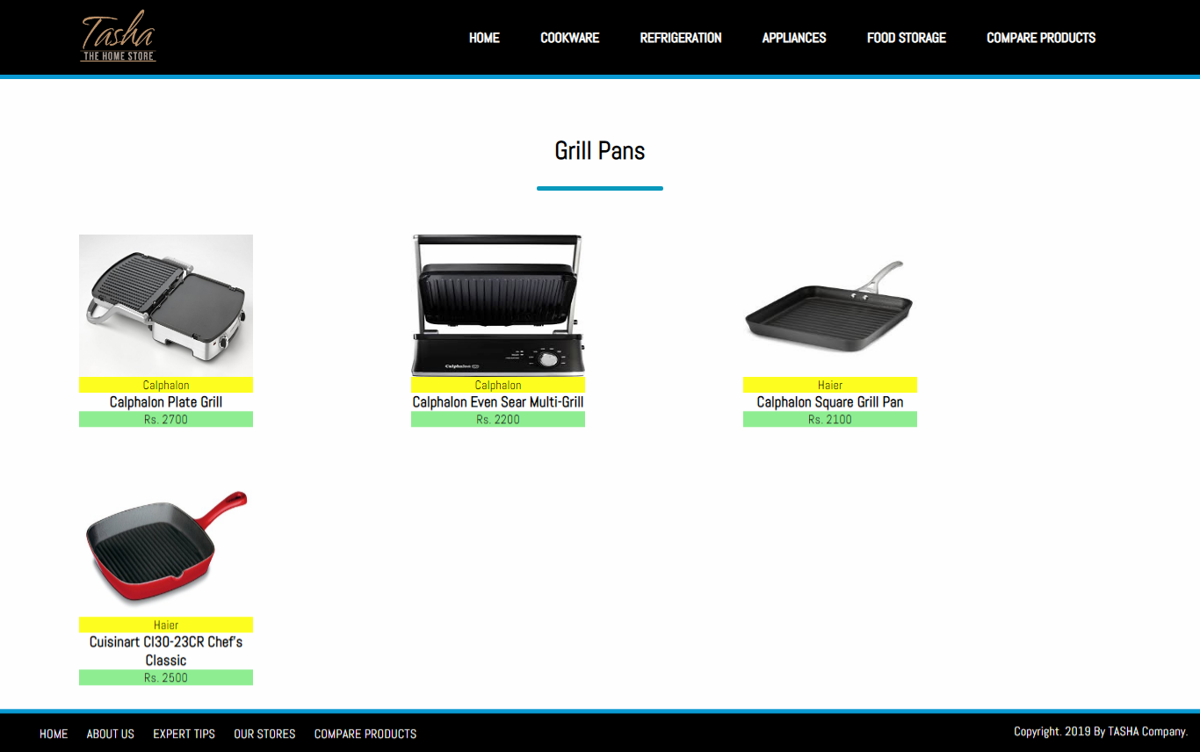*
* *TAWAS*

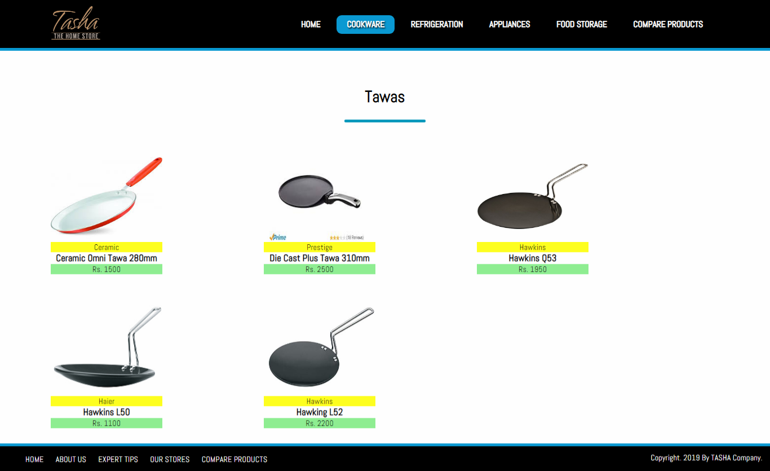

* *EGG POACHERS*

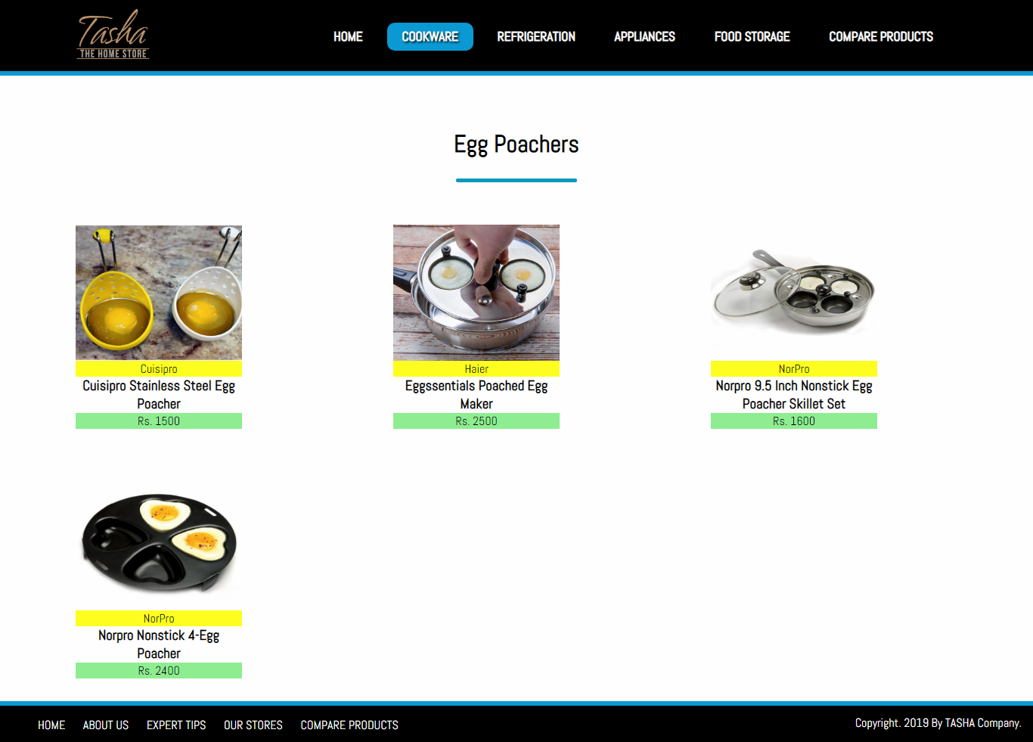

* *STEAMERS*

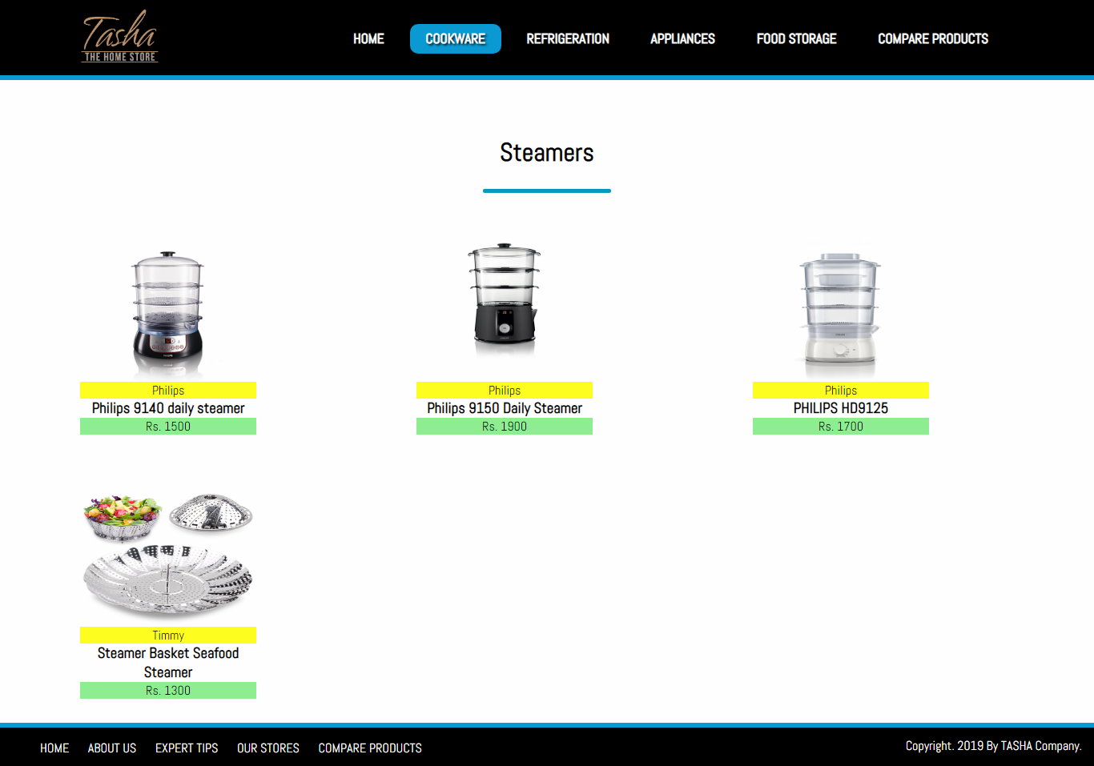

## SUB-DIVISIONS OF REFRIGERATION:

* *FREEZERS*

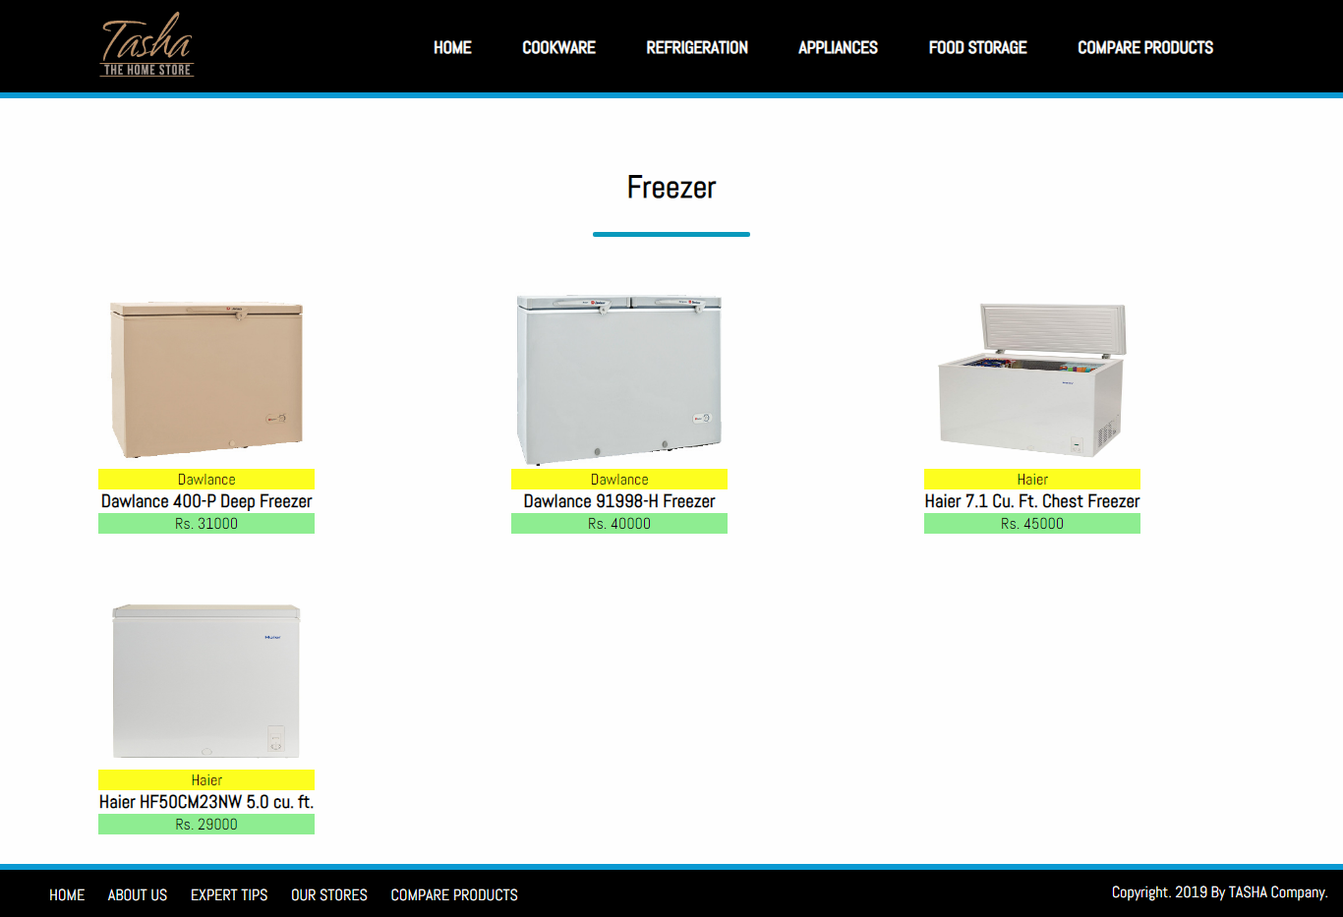

* *REFRIGERATOR*

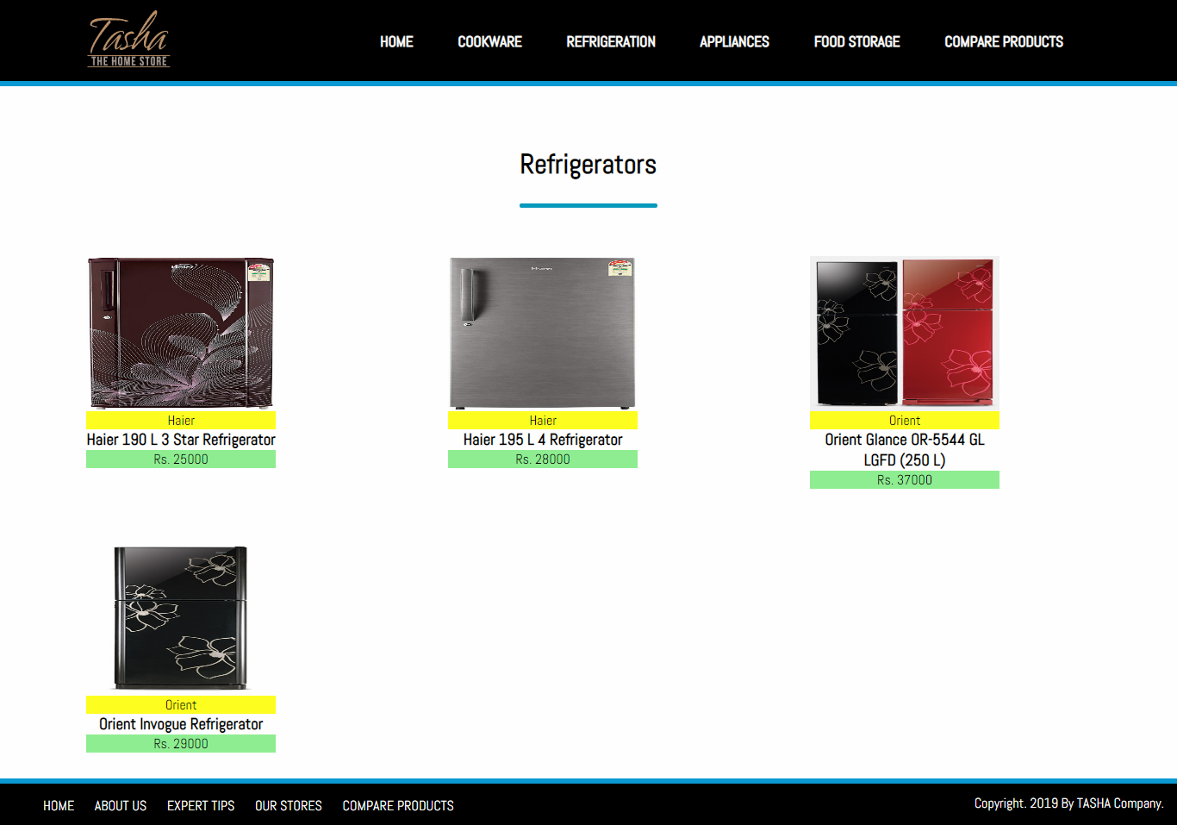

***SUB-DIVISIONS OF APPLIANCES:***

* *BLENDER*

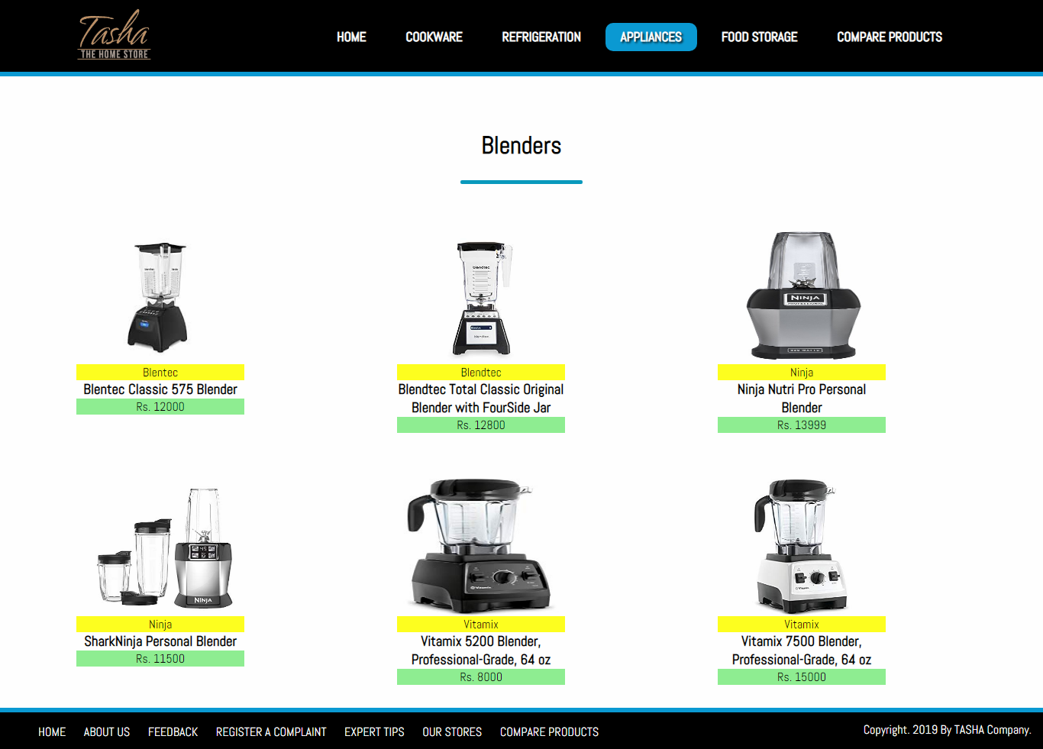

* *BREAD MAKER*

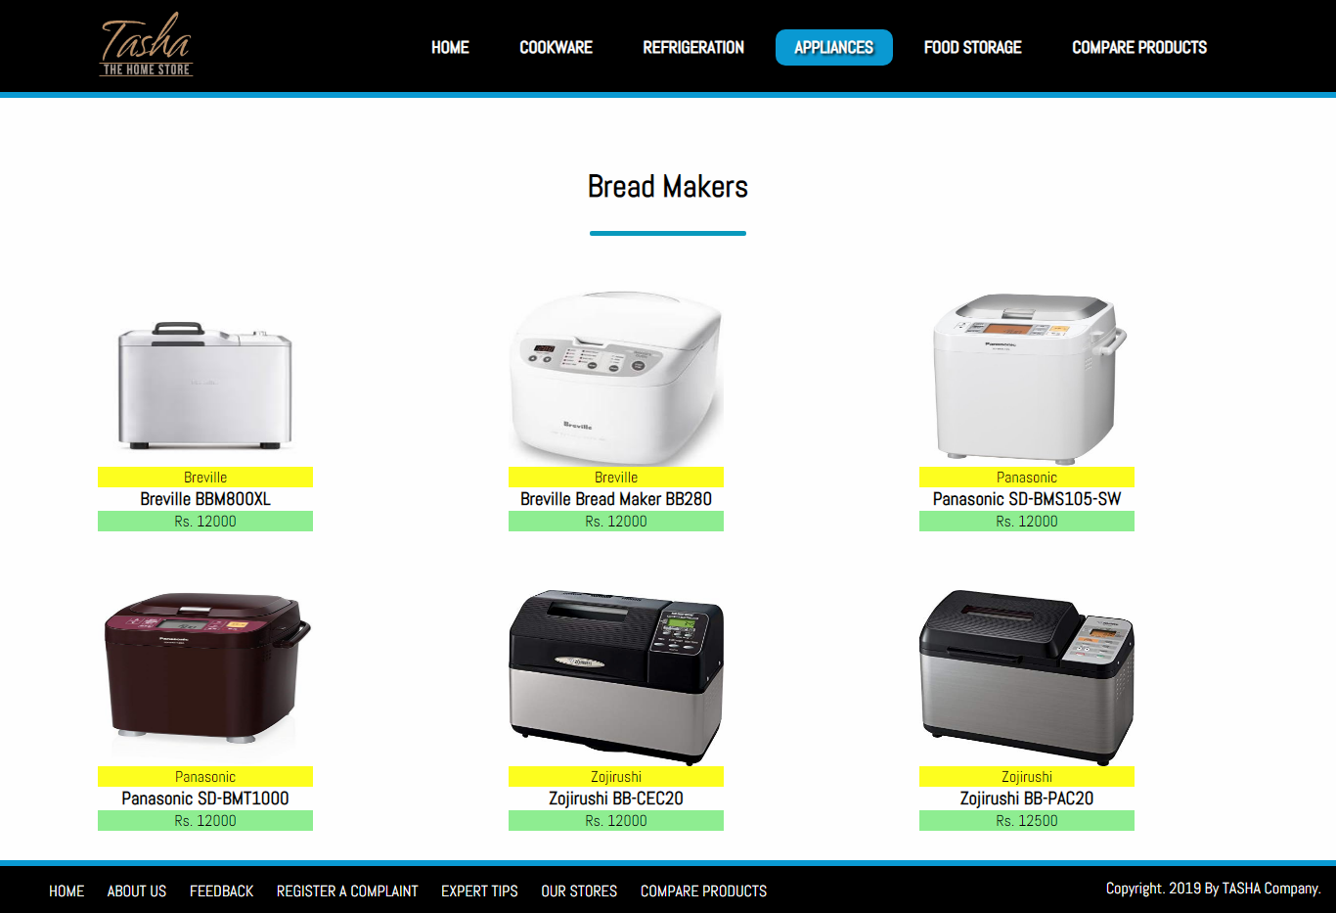

* *COFFEE MAKER*

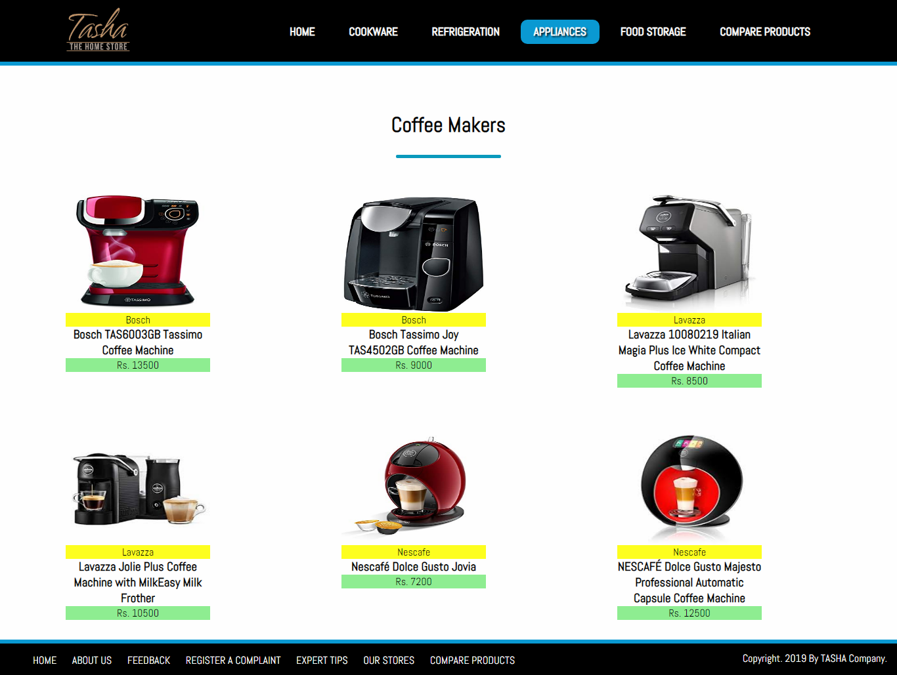

* *ICE CREAM AND SORBET MAKER*

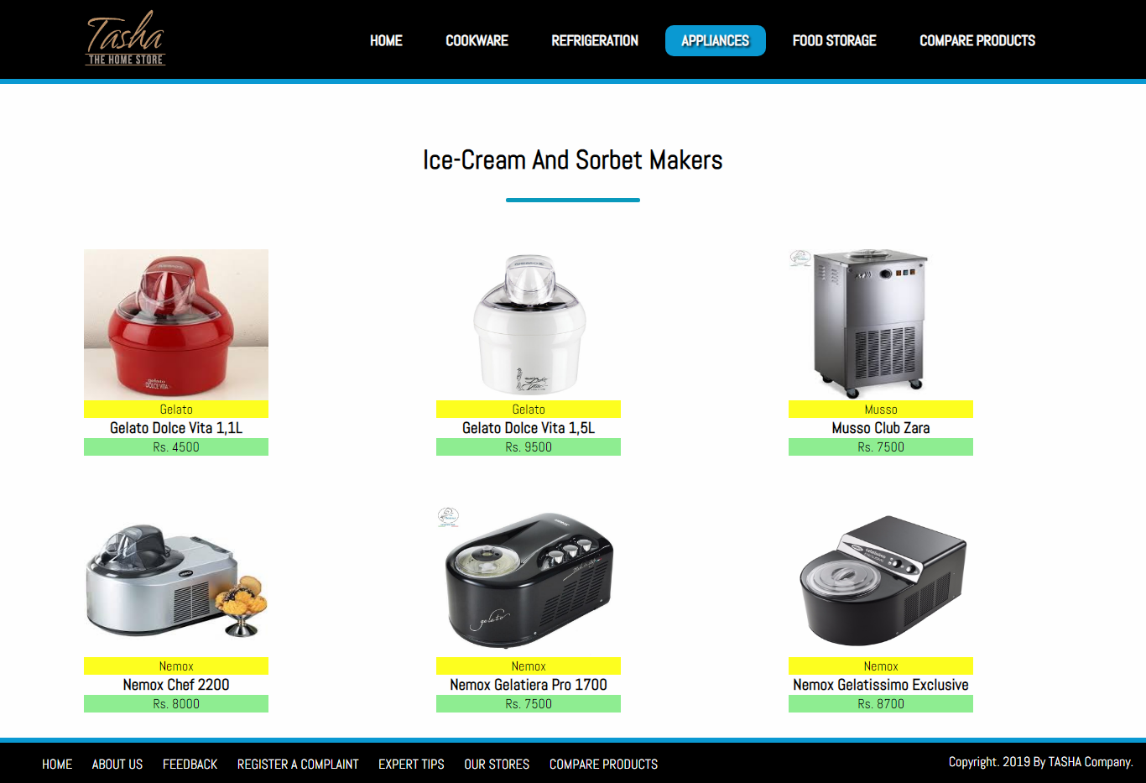

* *ELECTRIC KETTLE*

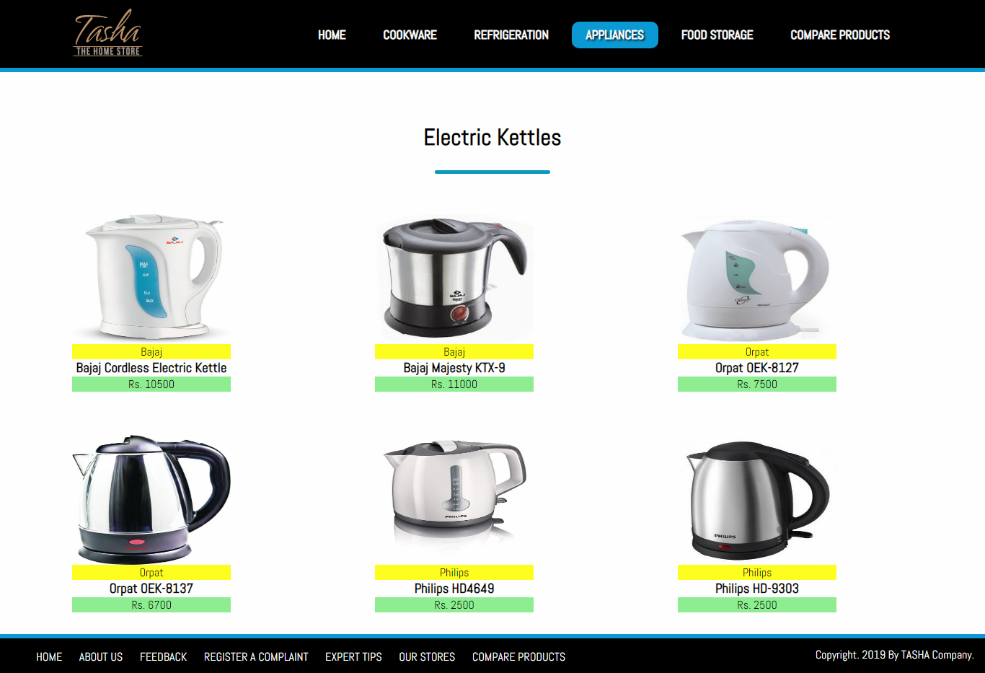

* *FOOD CHOPPER*

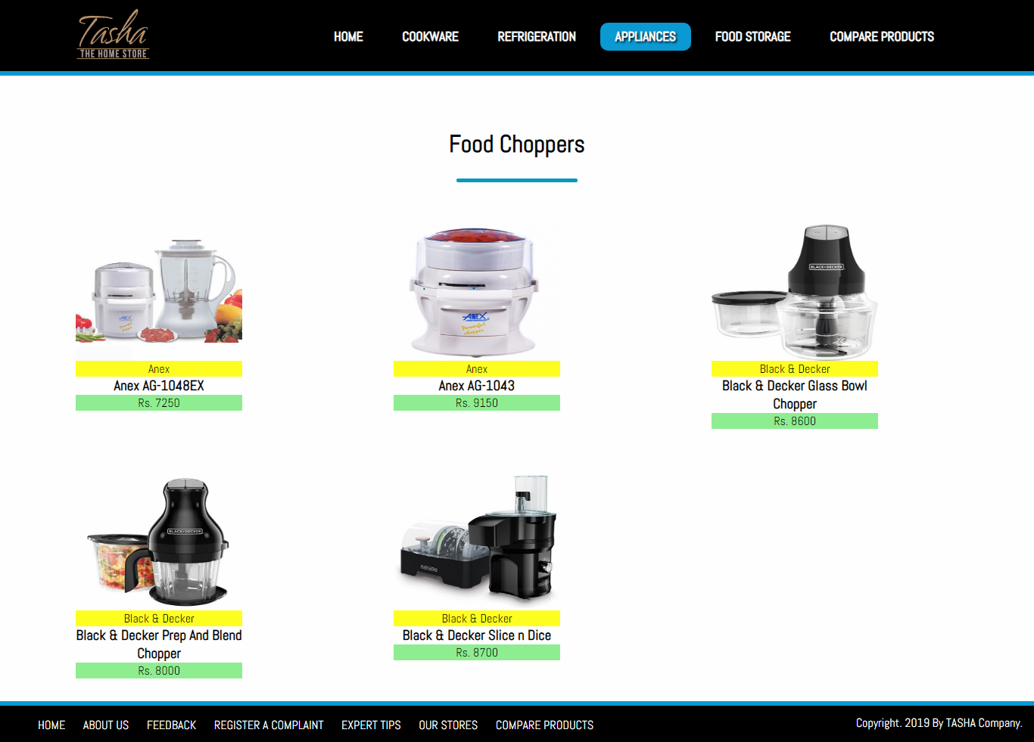

* *TOASTERS*

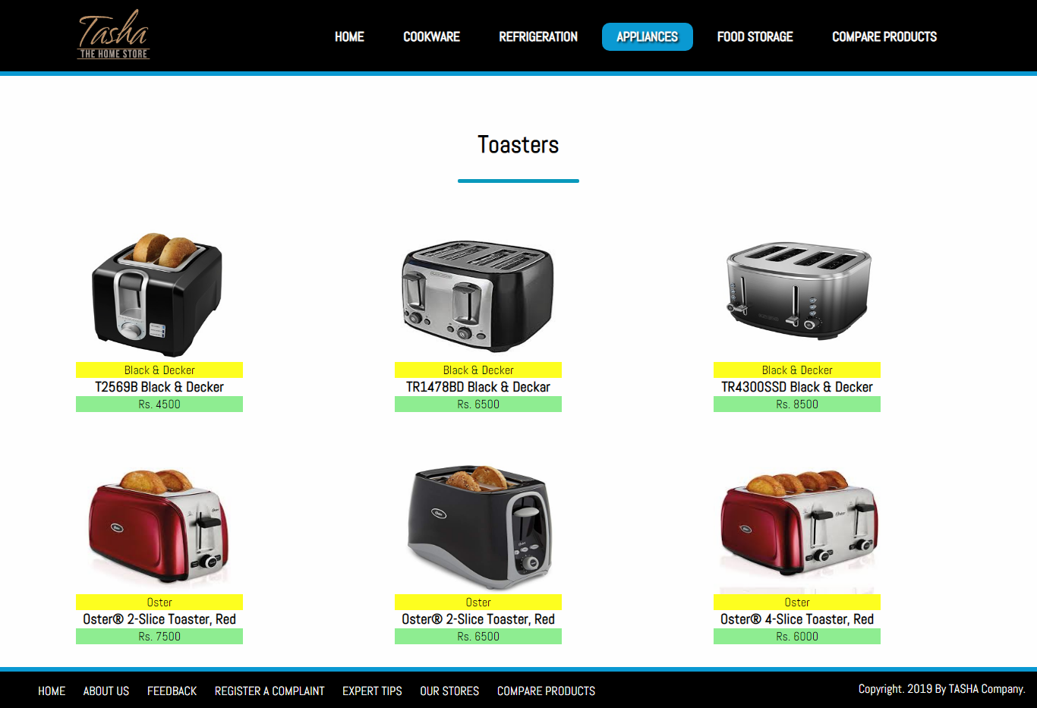

## SUB-DIVISIONS OF FOOD STORAGE:

* *FLASK*

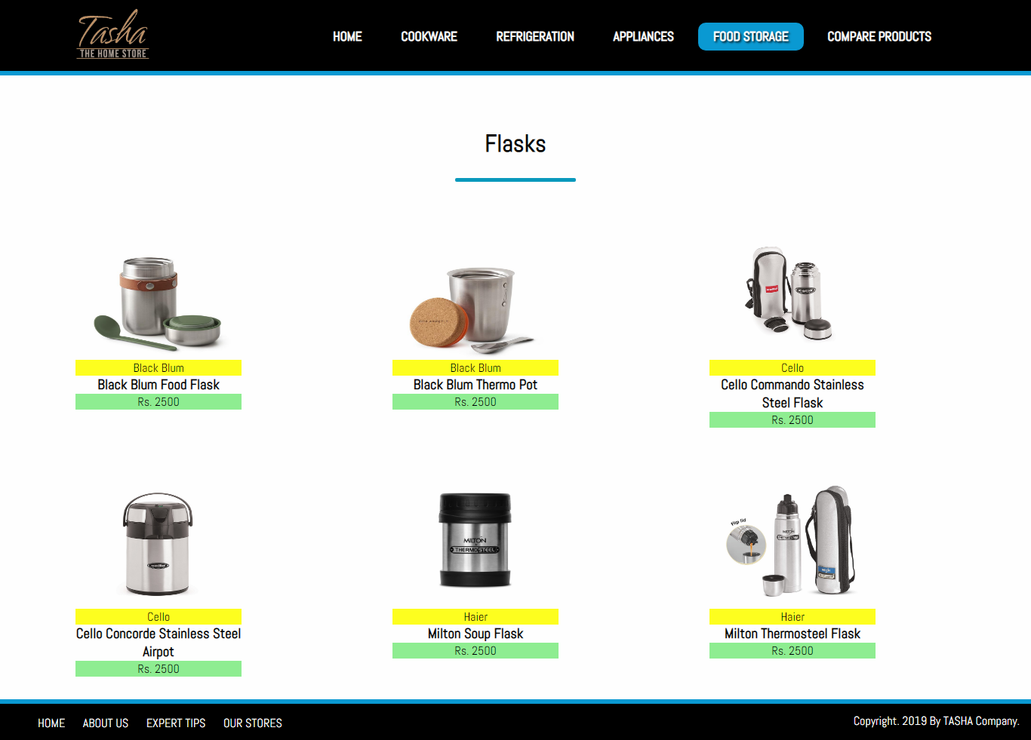

* *SPICE JARS*

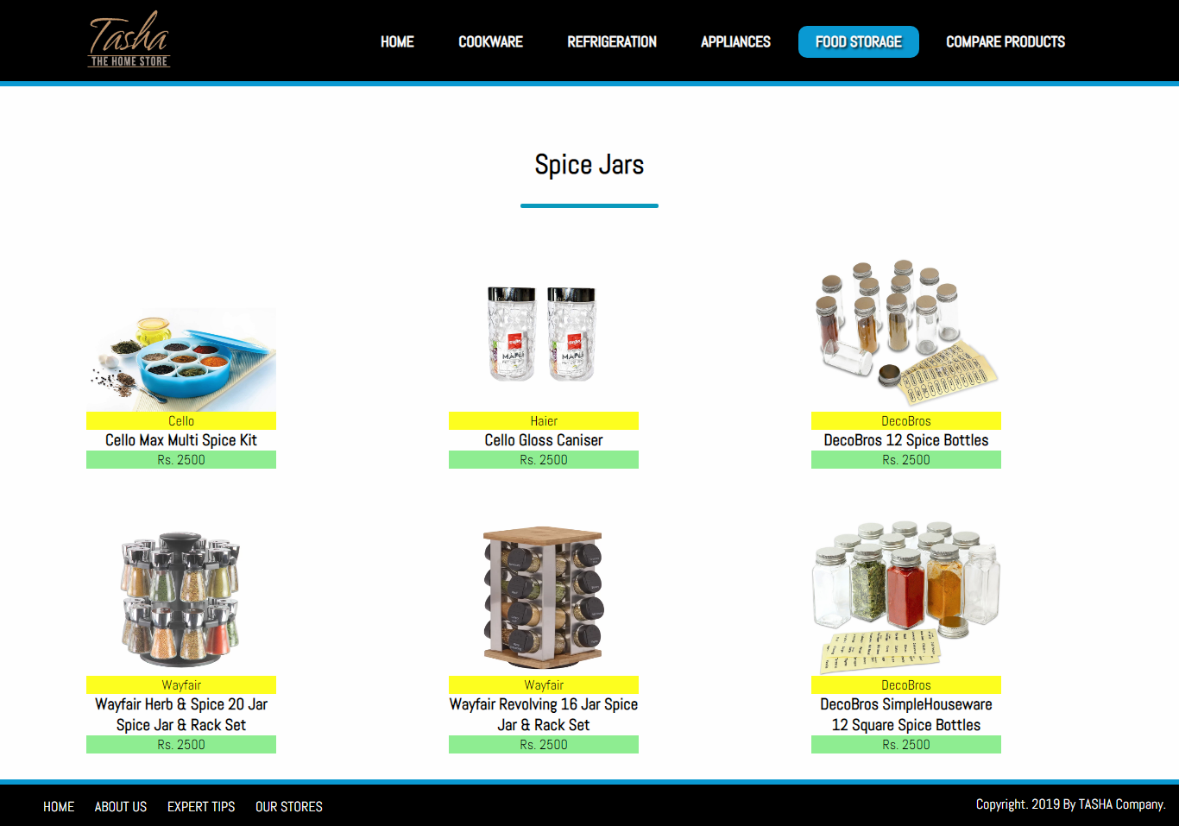

* *STORAGE BAGS*

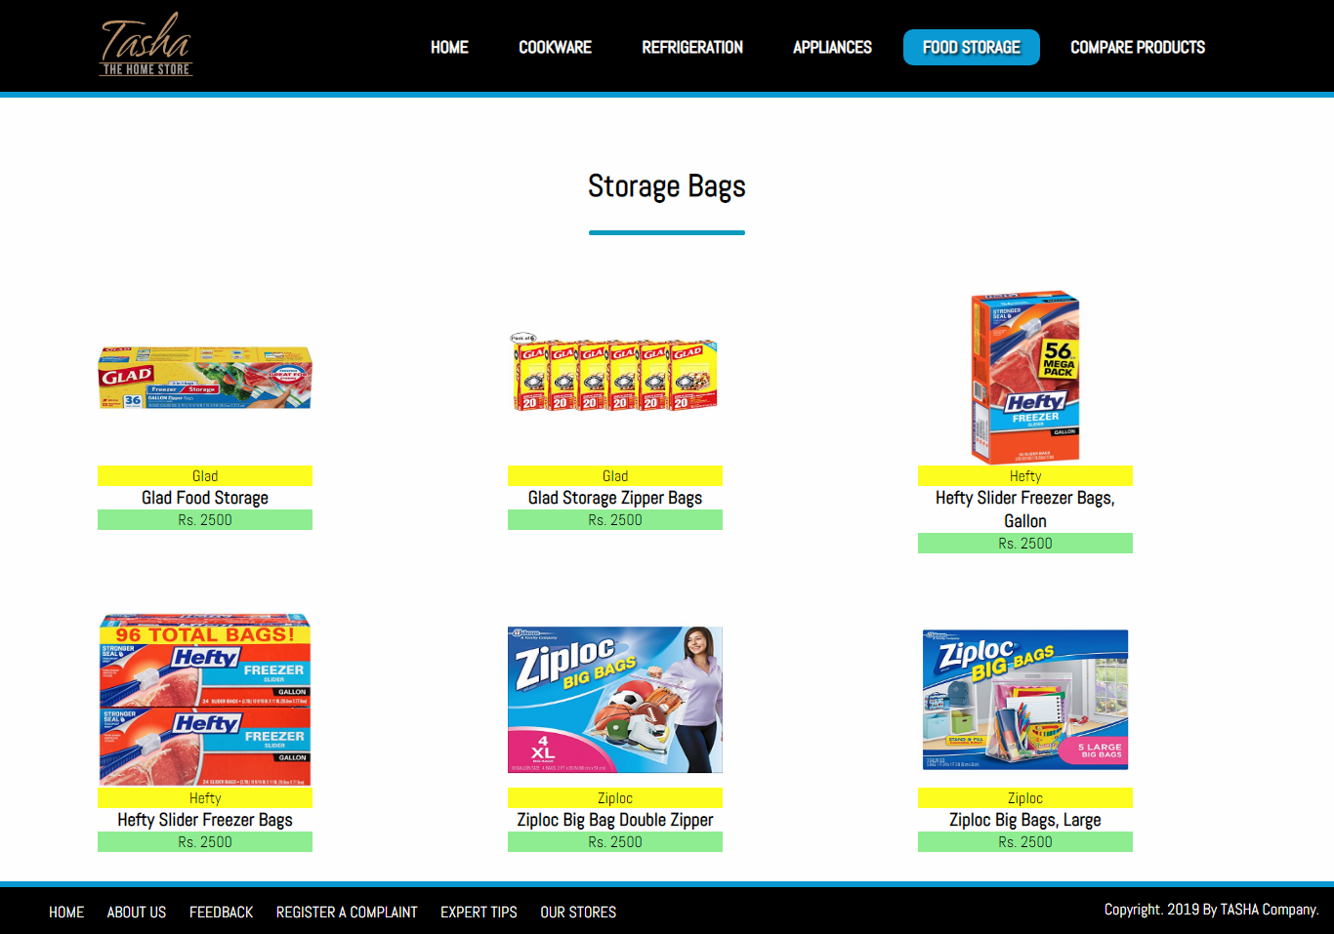

* *LUNCH BOXES*

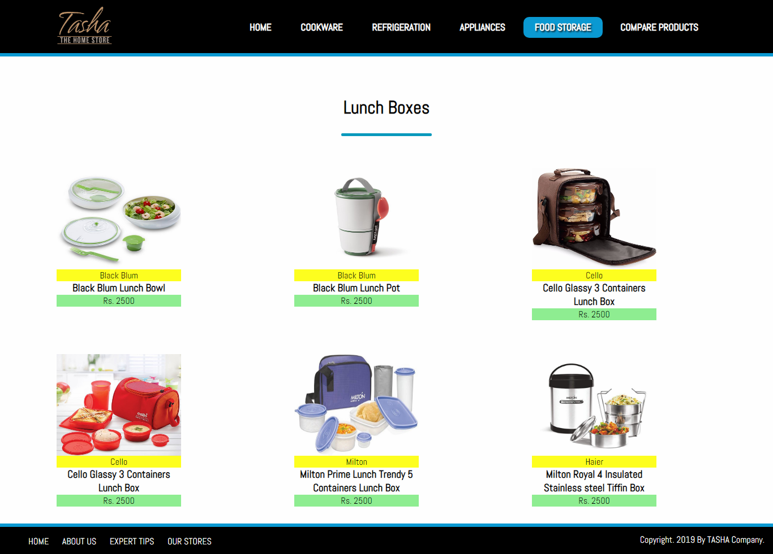

* *VACCUM BOTTLES*

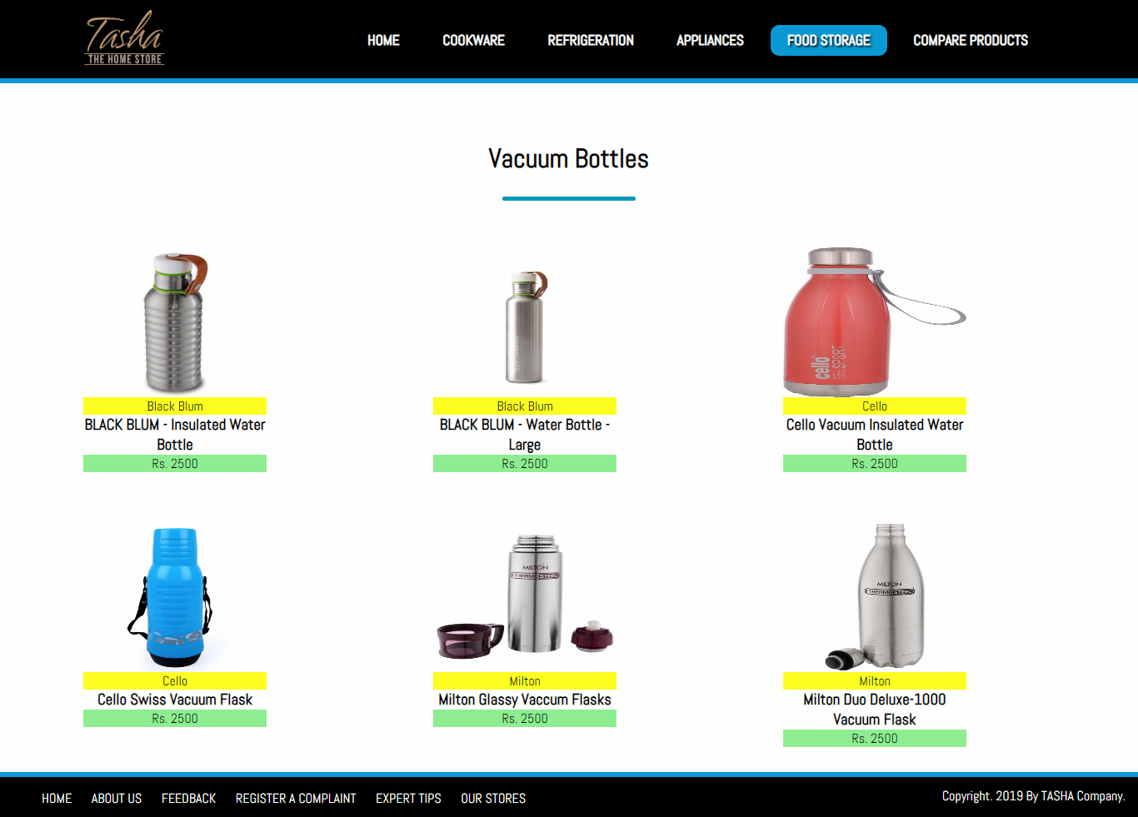

# *Developer’s Guide*

## COOKWARE

REFRIGERATION 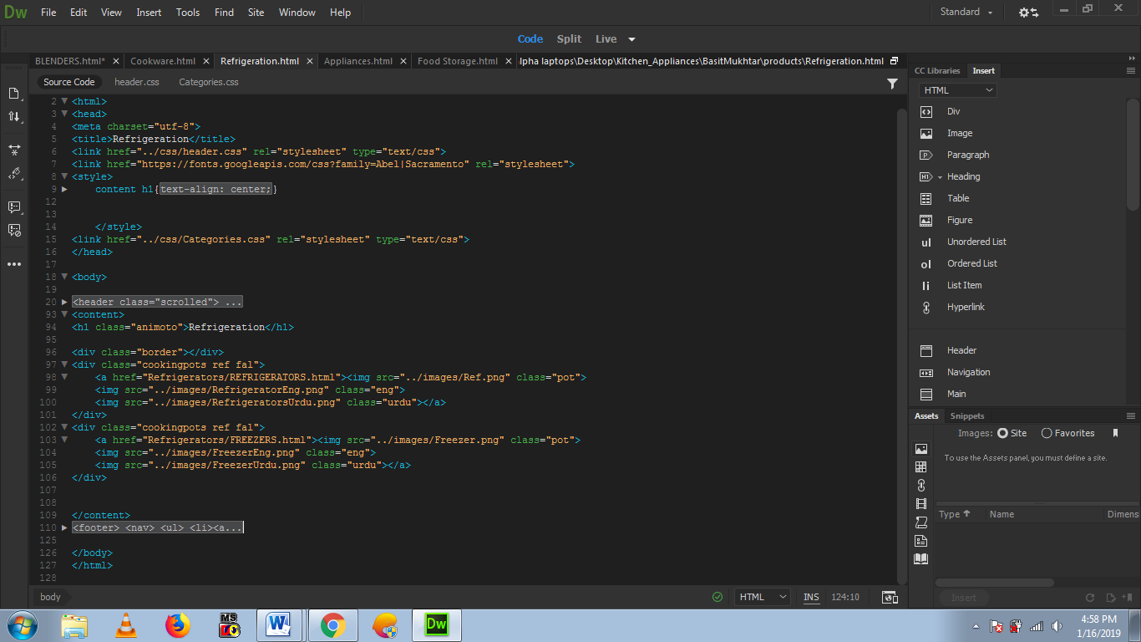

## APPLIANCES

## FOOD STORAGE

*Task Sheet*

|  |  |  |  |  |
| --- | --- | --- | --- | --- |
| Project Ref. No. | | Project Title | Date of Preparation of Activity Plan | |
| S.No. | Task | **Kitchen Appliances** | Actual Days | Status |
| 1 | Analysis | 1 | OK |
| 2 | Design | 2 | OK |
| 3 | Development | 5 | OK |
| 4 | Testing | 1 | OK |
| 5 | Documentation | 1 | OK |